- \(…)\Set-up carton transport
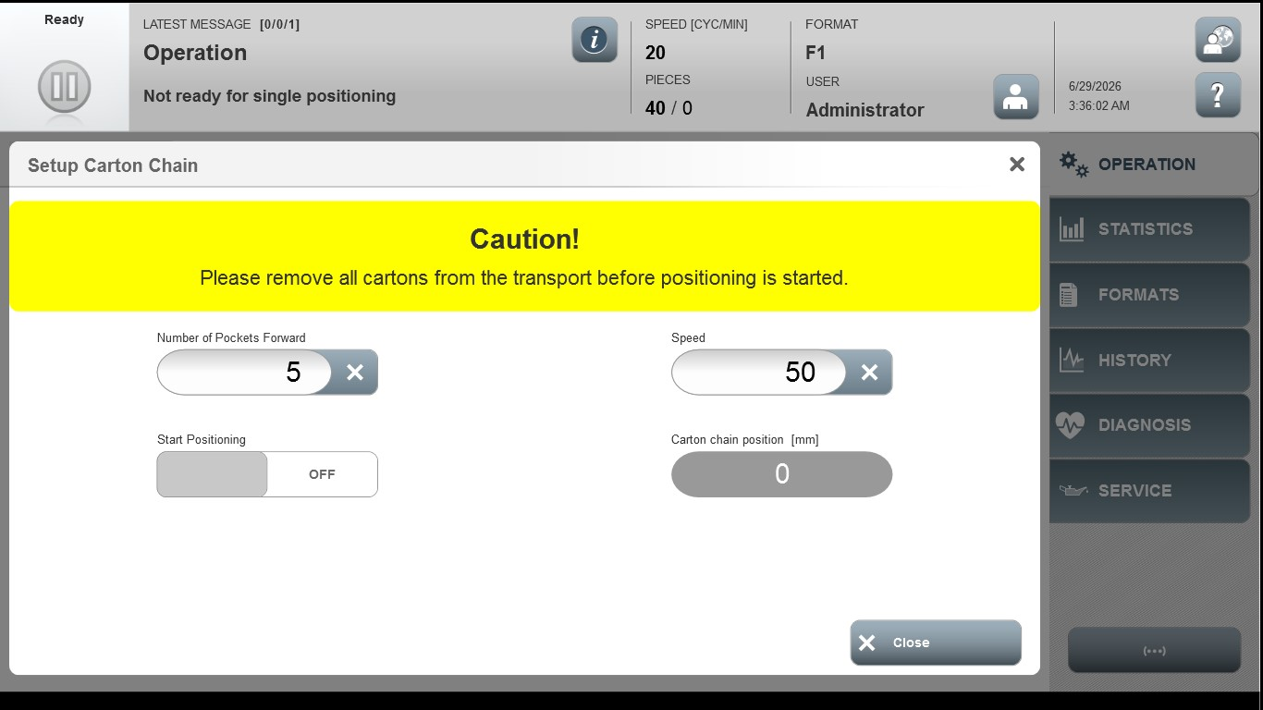
Acceptance criterion | Limits | Pass / Fail: Dev-No. | Date | Initials
Screen matches screenshot | N / A
Speed | 10…200
Number of Pockets Forward | 1…40

